Neural Networks and Machine Learning
7COM1033 (2025/2026)

Mock Test Model Answer and Marking Scheme (Volker)

Question 1: Associative Networks

- The following diagram shows an associative (Willshaw) net with four input units and four output units. In this network, 14 of the 16 synapses are switched off. The two synapses that are switched on are marked by a black dot. The association between which input pattern and which output pattern has been stored (4 marks)?

input units
output units

Answer: The association between input pattern (0, 1, 1, 0) and output pattern (0, 1, 0, 0).

- Store the following input-output pattern pairs in an associative net: input pattern 1 = (0, 0, 1, 1), output pattern 1 = (0, 1, 1, 0); input pattern 2 = (1, 0, 0, 1), output pattern 2 = (0, 1, 0, 1). Redraw the net and label the synapses that have been switched on (7 marks).

Answer (one mark for each correct synapse that is on, minus one mark for false positives):

input units
output units

- Present input pattern 1 and try to recall the correct output pattern. What are the input sum, threshold and resulting activation of each of the four output units (6 marks)?

Answer (0.5 marks for each of the 12 values):

Output unit 1 2 3 4
Input sum 0 2 2 1
Threshold 2 2 2 2
Output activation 0 1 1 0

Question 2: Perceptrons

- In a simple threshold linear unit (perceptron) with two inputs x₁ and x₂ and weights w₁ and w₂, how is the output y calculated (4 marks)?

Answer:
y = 1 if w₁ x₁ + w₂ x₂ ≥ θ
y = 0 otherwise

- Draw the input space (including all four input patterns with an indication of their target outputs and a potential decision line) for the following classification task (5 marks):

x₁ x₂ target output

0 0 0
0 2 0
0 4 1
2 0 1

Answer:
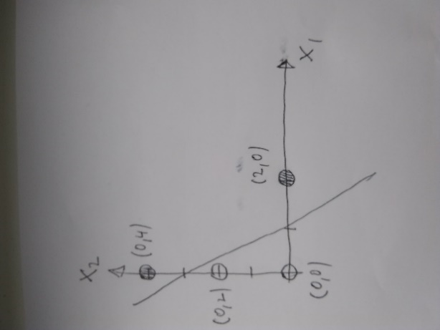

- Give the equation that describes your decision surface (3 marks).

Answer: x₂ = -3 x₁ + 3

- Give potential weights w₁ and w₂ and a potential threshold θ for the decision surface (3 marks).

Answer: -w₁/w₂ = -3 and θ/w₂ = 3 so a possible answer is w₁ = θ = 3, w₂ = 1

Question 3: Unsupervised Learning

Assume a Kohonen Network (Self-Organising Map) with two input units and a physical grid of 3 x 3 = 9 output units a, b, c, d, e, f, g, h, i. The weight vectors of the output units are initially given by (shown by their physical arrangement in output space):

w_{a} = (1, 5) | w_{b} = (2, 3) | w_{c} = (4, 1)
w_{d} = (5, 1) | w_{e} = (3, 2) | w_{f} = (1, 4)
w_{g} = (5, 5) | w_{h} = (3, 3) | w_{i} = (1, 1)

- The network is presented with an input vector x = (1, 0). Which output unit will be the winner and why (4 marks)?

Answer: Output unit i will be the winner as its weight vector is closest to the input vector.

- Assuming a learning rate α = 0.5, what will the weight vector of the winning output be changed to after a single presentation of the input vector x = (1, 0) (4 marks)?

Answer: The weight vector w_{i} = (1, 1) will be changed to w_{i,new} = (1, 0.5).

- The network from (a) is presented with a large number of inputs where x₁ and x₂ are chosen randomly from values between 0 and 5. Draw the final state of the network both in (mathematical) input space and in (physical) output space (4 marks).

Answer:

